**EBS Migration:**

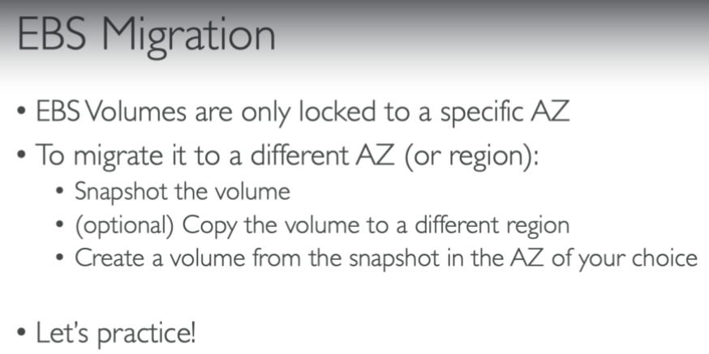

* We first need to create a snapshot from a volume. Then right click on snapshot and select create volume option as below.

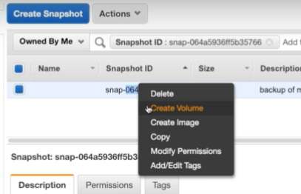

* Now, we can select whatever the availability zone we want as below.

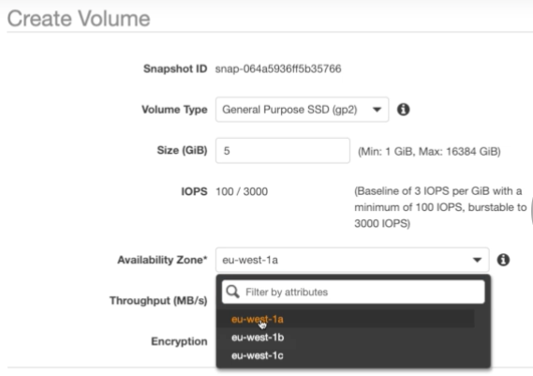

* If we want to copy the snapshot between regions, then we need to use the copy option as below.



* Now, we can select the region whichever we want.

